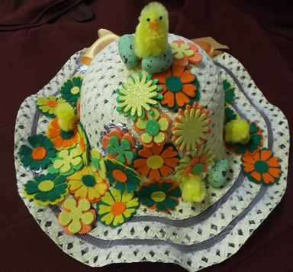
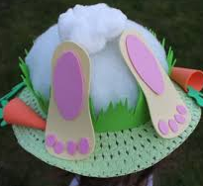
Easter Bonnet Parade

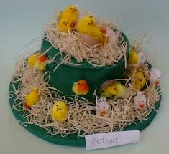
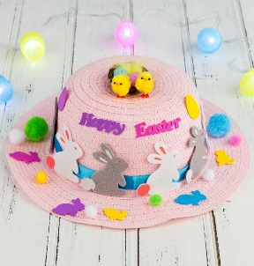

As part of our Easter celebrations this term, we will be having an Easter Bonnet parade in Nursery. This will be held on Thursday 29th March 2018. The children will wear their bonnets for our special parade!

We thought it would be fun for parents/carers to get involved in this with the children at home and therefore the children can choose whichever design they like. It can be a traditional bonnet or maybe a baseball cap.

